web-Based Intelligent Traffic Management

System

# I. INTRODUCTION

With the increase in urbanization, many cities around the world are experiencing a very rapid growth in the number of vehicles which lead to serious traffic congestion problems. This places a greater demand on operating roadway systems with maximum efficiency. One major factor that affects the traffic flow is the management of the traffic at road intersections. Hence a good traffic management system is needed to maximize the efficiency of the traffic flow. In traditional TMS, each intersection is controlled by its own controller which sends signals to the intersection’s traffic lights for changing their states.

Manuscript received June 26, 2009. This work was supported by the Deanship of scientific Research.

Author is with the Department of Electrical and Electronic Engineering at the University of Bahrain.

Each intersection controller works independently of other intersections’ controller with no way of being remotely controlled or monitored.

Today, with the wide availability of high bandwidth internet connectivity and the miniaturizing of web servers, the process of remotely monitoring and controlling various systems became more achievable. Embedded Web Server (EWS) has emerged to simplify the design process of systems that needs to be connected to the internet for the purpose of monitor and control. Most EWS are microcontrollers that support the sophisticated and well established TCP/IP communication standard. Hence, EWS based devices (internet appliances) can be plugged into any Ethernet network, allowing users to monitor and control their embedded applications using any standard browser. This has caused a strong trend towards embedding internet capability in many different areas such as industrial control [1], power-supply monitoring and control [2], environmental monitoring [3], telecommunications, robotics [4], healthcare [5], home security [6] and many consumer electronic devices.

In this work we have utilized the emerging EWS technology to design a web-based traffic management system that can remotely control and monitor the traffic at various intersections simultaneously. The system is aimed at improving the traditional TMS by incorporating better management and monitoring schemes as well as providing road users with real time information through VMS.

The paper is organized as follows: In Section II, we start with an overview of the proposed traffic management system. In Section III, we present the hardware and software platforms required to implement the system, followed by the system operation in section IV. Discussion of future work and concluding remarks are found in Sections V.

**II.** INTELLIGENT TRAFFIC MANAGEMENT SYSTEM

The intelligent traffic management system proposed in this paper consists of a master unit and a number of slave nodes sparsely located at different geographical sites and interconnected together through the internet.

The master unit is the Central Traffic Management Unit (CTMU) used to remotely monitor and control the different nodes using the internet as the communication backbone, as shown in figure 1.

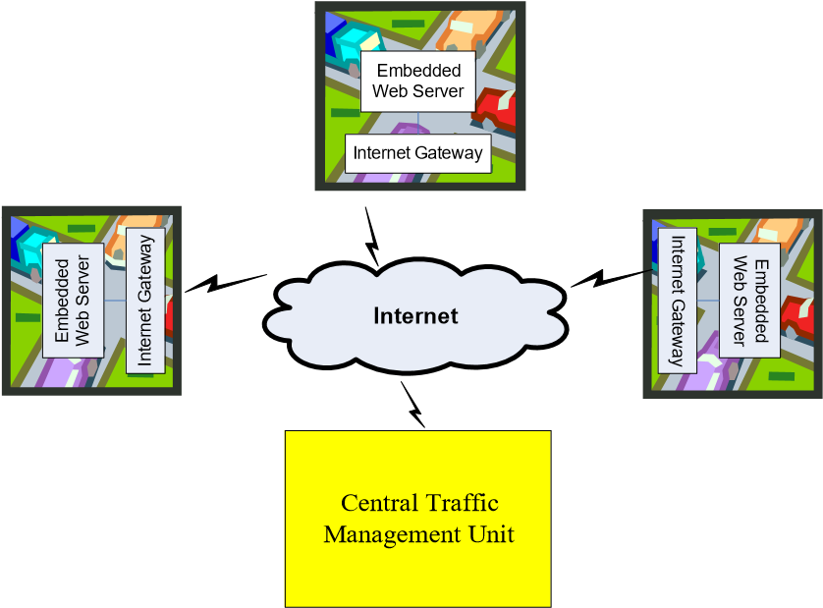

## Figure 1 Web-Based Traffic Management System

Each node is equipped with an embedded web server which is responsible for monitoring and controlling the traffic signals, traffic sensors, camera and/or the electronic variable message sign (EVMS) located at a specific intersection as shown in figure 2. In this configuration, the CTMU acts as the client while each node act as a server in a client-server model.

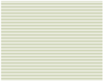

VMS

Camera

Intersection Embedded Web Server

Vehicle

Detectors

Traffic

Signals

Variable

Message Sign

## Figure 2. Node’s Embedded Web Server

Each embedded web server facilitates the process of sending/receiving data to/from remote locations and exchange information with one another via the CTMU, whereby, traffic problems can be detected, analyzed and corrected quickly.

The embedded web server of every node is identified by its unique IP address and can be controlled remotely by CTMU.

The EWS send or receive the desired information using HTML documents which has the ability to be generated dynamically using the Common Gateway Interface (CGI) [7]. HTTP protocol is the protocol that is used to allow the CTMU to request status or control the web servers at the different nodes. The web server must include enough memory to hold the software that facilitates its networking ability. An optimized TCP/IP stack is implemented into the web server ROM. In addition, external SRAM is required for buffering incoming data, while an external flash memory is needed to store the html web information and the traffic signal control application software. The CTMU will act as the web client when monitoring and controlling the nodes via a standard web browser.

# III. SYSTEM IMPLEMENTATION

A prototype of the proposed system has been built with two nodes. Each node controls and monitors an intersection of two roads called A and B. A circuit board with LEDs arranged like traffic lights around the two road intersection plus two switches for sensing traffic flow in each direction is interfaced with each node controller. Each node is also equipped with Alpha-numeric LCD Display that emulates a Variable Message Sign (VMS) used to display traffic information about special events such as traffic congestion, road works, speed limits or accidents.

1. *The Central Traffic Management Unit Platform*

The CTMU is implemented on a personal computer that is able to monitor and control each node separately. A front panel Graphical User Interface (GUI) is developed to interact with the different nodes via the internet using Visual Basic. When a node is selected for monitoring or control, an internet browser will be invoked and the IP address of the selected node will be entered at the URL field of the browser. The browser will request a connection with the selected node, and upon successful connection, the embedded web server will respond by sending back an HTML page containing information about the node and an HTML form to select the access mode of the EWS, i.e; monitoring or controlling its environment.

1. *Nodes Software and Hardware Platform*

The embedded web server of each node was implemented using the new microchip PIC18F97J60 microcontroller which operates at 10 MIPS/40 MHz [7]. The PIC18F97J60 is low power consumption, high performance RISC CPU with integrated 10BASE-T Ethernet (IEEE 802.3) controller and peripheral on chip. The chip is mounted on PIC development platform. It has been selected because it offers a single chip solution to embedded web server by integrating an IEEE 802.3 compatible Ethernet controller into the same chip. The microcontroller has also a built-in 8 KB Dedicated Ethernet Buffer as well as a 128KB Program Flash to store the TCP/IP stack as well as the traffic monitoring and control application. By surveying the market for the available embedded web servers we found that this system is one of the most cost effective solutions that require minimum external hardware, hence decreasing the design complexity. In addition, the PIC18F97J60 is provided with excellent software support using Microchip MPLAB Integrated Development Environment.

The six traffic signals LEDs (three signals per road: Red, yellow, green) and the two traffic sensing switches are interfaced to port C, while the LCD is connected to port A and B of the controller.

A decision algorithm for operating the traffic signals on the intersection of two main roads A and B is programmed into the microcontroller’s flash ROM. The source code for controlling the traffic at the intersection is written in C language and loaded into the on-chip flash ROM. The algorithm operates the traffic signal in a standard cyclic mode taking care of the status of the traffic sensing switches to change the normal sequence according to the presence or absence of traffic at one of the roads.

# IV. SYSTEM OPERATION

Through the GUI of the CTMU the user can select the intersection to be monitored or controlled and a web browser will be invoked with an embedded Java applet that allows the user to select the desired mode of operation (Monitor or control) for the selected intersection. This is shown in figure 3.

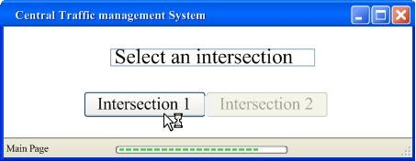

Figure 3. *GUI for accessing the Node’s servers.*

The selected node’s EWS sends or receives the desired information using HTTP, and the TCP/IP stack manages the entire communication. The embedded web server at the selected node will send its status as dynamic contents inserted into the HTML file, hence generating a Dynamic HTML file, which will be translated to a web page by the CTMU WEB browser. The dynamic web page content will be responsible for the timely updating of the traffic signal and sensors status. This has been achieved by writing a C script to monitor the traffic status and automatically insert periodic information into the node’s HTML file.

Figure 4 shows the software modules that run at each node server.

Traffic Signal Operation Program

C Script

HTTP

TCP/IP

Web pages HTML

Monitor Page

Control Page

Traffic Signals, Sensors, LCD

Ethernet

**Embedded Web Server Software**

Figure 4. *Software modules that run at each node server*

When the user at the CTMU clicks on the selected intersection, the corresponding node Web page will be invoked, indicating the current status of the intersection traffic. This is illustrated in figure 5.

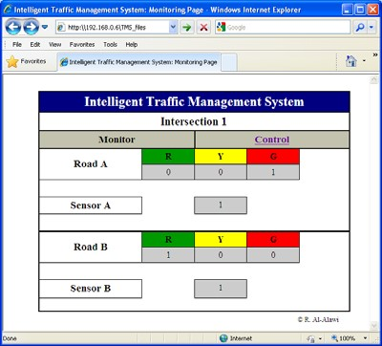

Figure 5. *Node Monitoring Web page.*

By clicking into the control tab, the user at the CTMU can remotely alter the operation of the traffic signal by selecting one out of four different options as shown in figure 6. In this case, the CTMU sends a GET command through the web browser using standard radio buttons input control. When the request is received by the EWS, it parses the request and converts it to a command that interact with the traffic light application program. Hence, the traffic light will operate according to the selected option through the CTMU. A message can also be entered through the web form and it will be displayed into the intersection’s LCD.

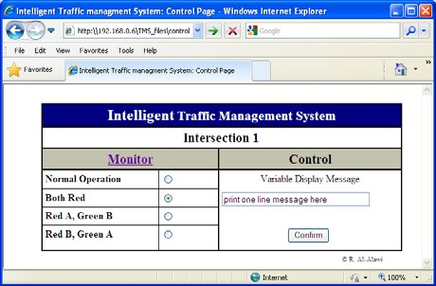

*Figure 6. Node Control Web page.*

import cv2

import dlib

import time

import threading

import math

import helm

carCascade = cv2.CascadeClassifier('cars.xml')

bikeCascade = cv2.CascadeClassifier('motor-v4.xml')

video = cv2.VideoCapture('test.mp4')

LAG=7

WIDTH = 1280

HEIGHT = 720

OPTIMISE= 7

def estimateSpeed(location1, location2,fps):

d_pixels = math.sqrt(math.pow(location2[0] - location1[0], 2) + math.pow(location2[1] - location1[1], 2))

# ppm = location2[2] / carWidht

ppm = 8.8

d_meters = d_pixels / ppm

if fps == 0.0:

fps = 18

speed = d_meters * fps * 3.6

return speed

def trackMultipleObjects():

rectangleColor = (0, 255, 0)

frameCounter = 0

currentCarID = 0

currentBikeID=0

fps = 0

carTracker = {}

bikeTracker = {}

bikeNumbers = {}

carNumbers = {}

bikeLocation1 = {}

carLocation1 = {}

bikeLocation2 = {}

carLocation2 = {}

speed = [None] * 1000

go =[False for i in range(1000)]

identity = [0 for i in range(1000)]

snaps = [False for i in range(1000)]

types = ["cars" for i in range(1000)]

Helmets = ["No Helmet Detected" for i in range(1000)]

out = cv2.VideoWriter('outpy.avi',cv2.VideoWriter_fourcc('M','J','P','G'), 10, (WIDTH,HEIGHT))

while True:

start_time = time.time()

rc, image = video.read()

if type(image) == type(None):

break

image = cv2.resize(image, (WIDTH, HEIGHT))

resultImage = image.copy()

frameCounter = frameCounter + 1

carIDtoDelete = []

for carID in carTracker.keys():

trackingQuality = carTracker[carID].update(image)

if trackingQuality < 7:

carIDtoDelete.append(carID)

for carID in carIDtoDelete:

print ('Removing carID ' + str(carID) + ' from list of trackers.')

print ('Removing carID ' + str(carID) + ' previous location.')

print ('Removing carID ' + str(carID) + ' current location.')

carTracker.pop(carID, None)

carLocation1.pop(carID, None)

carLocation2.pop(carID, None)

if not (frameCounter % 10):

gray = cv2.cvtColor(image, cv2.COLOR_BGR2GRAY)

cars = carCascade.detectMultiScale(gray, 1.1, 13, 18, (24, 24))

bikes = bikeCascade.detectMultiScale(gray, 1.1 , 13, 18, (24,24))

for (_x, _y, _w, _h) in cars:

x = int(_x)

y = int(_y)

w = int(_w)

h = int(_h)

roi = image[y:y+h,x:x+w]

x_bar = x + 0.5 * w

y_bar = y + 0.5 * h

matchCarID = None

for carID in carTracker.keys():

trackedPosition = carTracker[carID].get_position()

t_x = int(trackedPosition.left())

t_y = int(trackedPosition.top())

t_w = int(trackedPosition.width())

t_h = int(trackedPosition.height())

t_x_bar = t_x + 0.5 * t_w

t_y_bar = t_y + 0.5 * t_h

if ((t_x <= x_bar <= (t_x + t_w)) and (t_y <= y_bar <= (t_y + t_h)) and (x <= t_x_bar <= (x + w)) and (y <= t_y_bar <= (y + h))):

matchCarID = carID

if matchCarID is None:

print ('Creating new tracker ' + str(currentCarID))

tracker = dlib.correlation_tracker()

tracker.start_track(image, dlib.rectangle(x, y, x + w, y + h))

carTracker[currentCarID] = tracker

carLocation1[currentCarID] = [x, y, w, h]

currentCarID = currentCarID + 1

for (_x, _y, _w, _h) in bikes:

x = int(_x)

y = int(_y)

w = int(_w)

h = int(_h)

x_bar = x + 0.5 * w

y_bar = y + 0.5 * h

matchCarID = None

for carID in carTracker.keys():

trackedPosition = carTracker[carID].get_position()

t_x = int(trackedPosition.left())

t_y = int(trackedPosition.top())

t_w = int(trackedPosition.width())

t_h = int(trackedPosition.height())

t_x_bar = t_x + 0.5 * t_w

t_y_bar = t_y + 0.5 * t_h

if ((t_x <= x_bar <= (t_x + t_w)) and (t_y <= y_bar <= (t_y + t_h)) and (x <= t_x_bar <= (x + w)) and (y <= t_y_bar <= (y + h))):

matchCarID = carID

if matchCarID is None:

print ('Creating new tracker ' + str(currentCarID))

tracker = dlib.correlation_tracker()

tracker.start_track(image, dlib.rectangle(x, y, x + w, y + h))

carTracker[currentCarID] = tracker

carLocation1[currentCarID] = [x, y, w, h]

types[currentCarID]= "bikes"

currentCarID = currentCarID + 1

for carID in carTracker.keys():

trackedPosition = carTracker[carID].get_position()

t_x = int(trackedPosition.left())

t_y = int(trackedPosition.top())

t_w = int(trackedPosition.width())

t_h = int(trackedPosition.height())

cv2.rectangle(resultImage, (t_x, t_y), (t_x + t_w, t_y + t_h), rectangleColor, 4)

carLocation2[carID] = [t_x, t_y, t_w, t_h]

end_time = time.time()

fps=0.0

for i in carLocation1.keys():

if frameCounter % 1 == 0:

[x1, y1, w1, h1] = carLocation1[i]

[x2, y2, w2, h2] = carLocation2[i]

carLocation1[i] = [x2, y2, w2, h2]

if [x1, y1, w1, h1] != [x2, y2, w2, h2]:

result = False

roi = resultImage[y1:y1+h1,x1:x1+w1]

if types[i]=="bikes" and Helmets[i] == "No Helmet Detected" and identity[i]< OPTIMISE:

result = helm.detect(roi)

if result==True:

Helmets[i]= "Helmet Detected"

if 7==7:

if not (end_time == start_time):

fps = 1.0/(end_time - start_time)

speed[i] = estimateSpeed([x1, y1, w1, h1], [x2, y2, w2, h2],fps)

if int(speed[i])>40:

speed[i]= speed[i]%40

if go[i] == True and int(speed[i])<10:

speed[i]=speed[i]+15

if int(speed[i])==0:

continue

if int(speed[i])>30:

go[i]=True

cv2.putText(resultImage, "OverSpeeding ALERT", (int(x1 + w1/2), int(y1-5)),cv2.FONT_HERSHEY_SIMPLEX, 0.75, (0, 0, 255), 2)

elif speed[i] != None and y1 >= 180 and speed[i]!=0:

ans= str(int(speed[i])) + " km/hr "

if types[i]=="bikes":

ans= ans+ Helmets[i]

cv2.putText(resultImage, ans, (int(x1 + w1/2), int(y1-5)),cv2.FONT_HERSHEY_SIMPLEX, 0.75, (0, 255, 0), 2)

identity[i]+=1

cv2.imshow('result', resultImage)

if cv2.waitKey(33) == 27:

break

cv2.destroyAllWindows()

if _name_ == '_main_':

trackMultipleObjects()

The main file to run the project…

from time import sleep

import cv2 as cv

import argparse

import sys

import numpy as np

import os.path

from glob import glob

#from PIL import image

frame_count = 0 # used in mainloop where we're extracting images., and then to drawPred( called by post process)

frame_count_out=0 # used in post process loop, to get the no of specified class value.

# Initialize the parameters

confThreshold = 0.5 #Confidence threshold

nmsThreshold = 0.4 #Non-maximum suppression threshold

inpWidth = 416 #Width of network's input image

inpHeight = 416 #Height of network's input image

# Load names of classes

classesFile = "obj.names";

classes = None

with open(classesFile, 'rt') as f:

classes = f.read().rstrip('\n').split('\n')

# Give the configuration and weight files for the model and load the network using them.

modelConfiguration = "yolov3-obj.cfg";

modelWeights = "yolov3-obj_2400.weights";

net = cv.dnn.readNetFromDarknet(modelConfiguration, modelWeights)

net.setPreferableBackend(cv.dnn.DNN_BACKEND_OPENCV)

net.setPreferableTarget(cv.dnn.DNN_TARGET_CPU)

# Get the names of the output layers

def getOutputsNames(net):

# Get the names of all the layers in the network

layersNames = net.getLayerNames()

# Get the names of the output layers, i.e. the layers with unconnected outputs

return [layersNames[i-1] for i in net.getUnconnectedOutLayers()]

# Draw the predicted bounding box

def drawPred(classId, conf, left, top, right, bottom, frame):

global frame_count

# Draw a bounding box.

#cv.rectangle(frame, (left, top), (right, bottom), (255, 178, 50), 3)

label = '%.2f' % conf

# Get the label for the class name and its confidence

if classes:

assert(classId < len(classes))

label = '%s:%s' % (classes[classId], label)

#Display the label at the top of the bounding box

labelSize, baseLine = cv.getTextSize(label, cv.FONT_HERSHEY_SIMPLEX, 0.5, 1)

top = max(top, labelSize[1])

#print(label) #testing

#print(labelSize) #testing

#print(baseLine) #testing

label_name,label_conf = label.split(':') #spliting into class & confidance. will compare it with person.

if label_name == 'Helmet':

#will try to print of label have people.. or can put a counter to find the no of people occurance.

#will try if it satisfy the condition otherwise, we won't print the boxes or leave it.

#cv.rectangle(frame, (left, top - round(1.5*labelSize[1])), (left + round(1.5*labelSize[0]), top + baseLine), (255, 255, 255), cv.FILLED)

#cv.putText(frame, label, (left, top), cv.FONT_HERSHEY_SIMPLEX, 0.75, (0,0,0), 1)

frame_count+=1

#print(frame_count)

if(frame_count> 0):

return frame_count

# Remove the bounding boxes with low confidence using non-maxima suppression

def postprocess(frame, outs):

frameHeight = frame.shape[0]

frameWidth = frame.shape[1]

frame_count_out=0

classIds = []

confidences = []

boxes = []

# Scan through all the bounding boxes output from the network and keep only the

# ones with high confidence scores. Assign the box's class label as the class with the highest score.

classIds = [] #have to fins which class have hieghest confidence........=====>>><<<<=======

confidences = []

boxes = []

for out in outs:

for detection in out:

scores = detection[5:]

classId = np.argmax(scores)

confidence = scores[classId]

if confidence > confThreshold:

center_x = int(detection[0] * frameWidth)

center_y = int(detection[1] * frameHeight)

width = int(detection[2] * frameWidth)

height = int(detection[3] * frameHeight)

left = int(center_x - width / 2)

top = int(center_y - height / 2)

classIds.append(classId)

#print(classIds)

confidences.append(float(confidence))

boxes.append([left, top, width, height])

# Perform non maximum suppression to eliminate redundant overlapping boxes with

# lower confidences.

indices = cv.dnn.NMSBoxes(boxes, confidences, confThreshold, nmsThreshold)

count_person=0 # for counting the classes in this loop.

for i in indices:

i = i[0]

box = boxes[i]

left = box[0]

top = box[1]

width = box[2]

height = box[3]

#this function in loop is calling drawPred so, try pushing one test counter in parameter , so it can calculate it.

frame_count_out = drawPred(classIds[i], confidences[i], left, top, left + width, top + height, frame)

#increase test counter till the loop end then print...

#checking class, if it is a person or not

my_class='Helmet' #======================================== mycode .....

unknown_class = classes[classId]

if my_class == unknown_class:

count_person += 1

#if(frame_count_out > 0):

#print(frame_count_out)

if count_person >= 1:

path = 'test_out/'

# frame_name=os.path.basename(fn) # trimm the path and give file name.

#cv.imwrite(str(path)+frame_name, frame) # writing to folder.

#print(type(frame))

#cv.imshow('img',frame)

#cv.waitKey(800)

return 1

else:

return 0

#cv.imwrite(frame_name, frame)

# Process inputs

winName = 'Deep learning object detection in OpenCV'

cv.namedWindow(winName, cv.WINDOW_NORMAL)

def detect(frame):

#frame = cv.imread(fn)

frame_count =0

# Create a 4D blob from a frame.

blob = cv.dnn.blobFromImage(frame, 1/255, (inpWidth, inpHeight), [0,0,0], 1, crop=False)

# Sets the input to the network

net.setInput(blob)

# Runs the forward pass to get output of the output layers

outs = net.forward(getOutputsNames(net))

# Remove the bounding boxes with low confidence

# Put efficiency information. The function getPerfProfile returns the overall time for inference(t) and the timings for each of the layers(in layersTimes)

t, _ = net.getPerfProfile()

#print(t)

label = 'Inference time: %.2f ms' % (t * 1000.0 / cv.getTickFrequency())

#print(label)

#cv.putText(frame, label, (0, 15), cv.FONT_HERSHEY_SIMPLEX, 0.5, (0, 0, 255))

#print(label)

k=postprocess(frame, outs)

if k:

return 1

else:

        return 0

**OUTPUT**

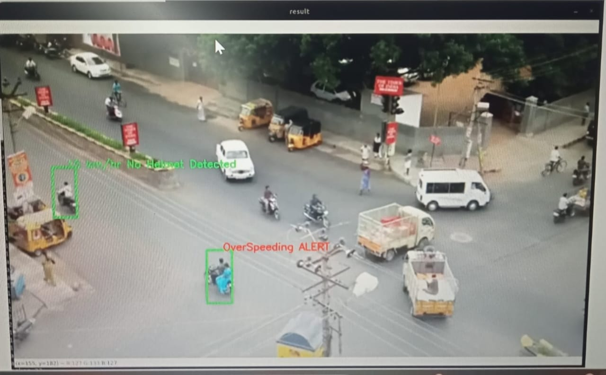

# V. CONCLUSIONS

With the increase in urbanization and traffic congestion, greater demand is placed on operating traffic systems with maximum efficiency. The intelligent traffic management system proposed in this work is a distributed automation systems based on Internet and Web technologies. The system uses the Ethernet as a communication backbone between individual nodes located at different traffic intersections and a central traffic management unit. Each node consists of an embedded web server interfaced with the traffic signals and used to monitors and control its operation. The proposed system offers a low cost solution to the needs of tomorrow’s traffic management. As future work, we will be looking into techniques for optimizing the method of generating the dynamic web pages.